**Data Structure**

**&**

**Algorithm**

**Class IX**

**Lab 8**

|  |
| --- |
| Lab Objectives:Data Structures summery from class 8 |

## Linear data structures maintain their data in an ordered fashion

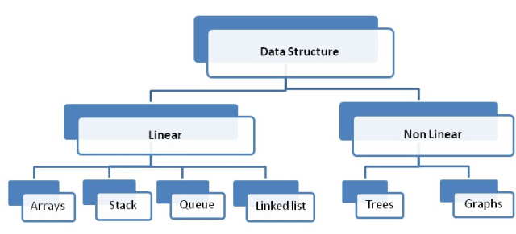

## IMG_256 Stacks are simple data structures that maintain a LIFO, last-in first-out, ordering.

## The fundamental operations for a stack are push, pop, and isEmpty.

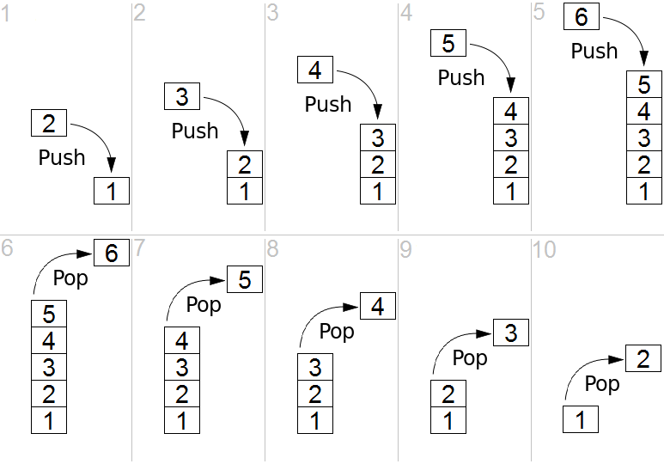

## Queues are simple data structures that maintain a FIFO, first-in first-out, ordering.

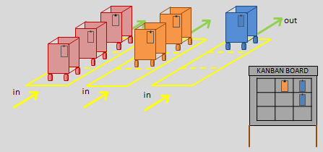

## The fundamental operations for a queue are enqueue, dequeue, and isEmpty.

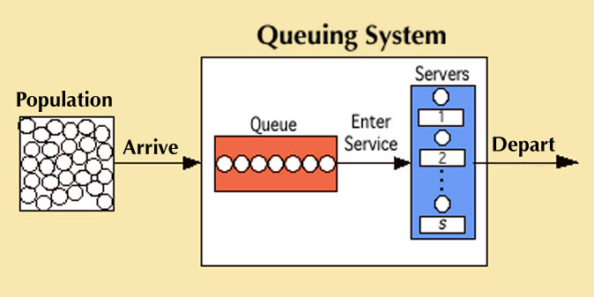

## Prefix, infix, and postfix are all ways to write expressions.

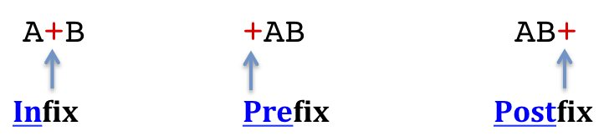

## IMG_256 Stacks are very useful for designing algorithms to evaluate and translate expressions.

## Deques are data structures that allow hybrid behavior like that of stacks and queues.

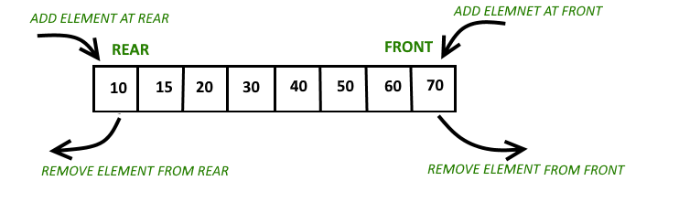

## The fundamental operations for a deque are addFront, addRear, removeFront,  removeRear, and isEmpty.

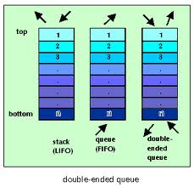

## Lists are collections of items where each item holds a relative position.

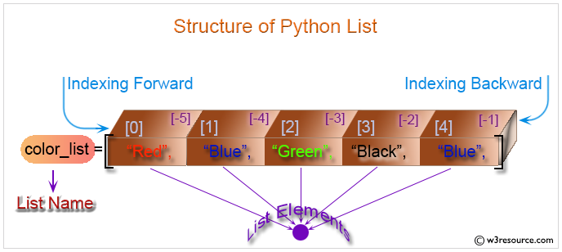

## A linked list implementation maintains logical order without requiring physical storage requirements.

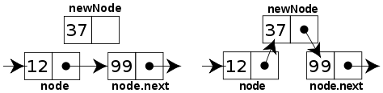

## In a singly-linked list every element contains some data and a link to the next element, which allows to keep the structure

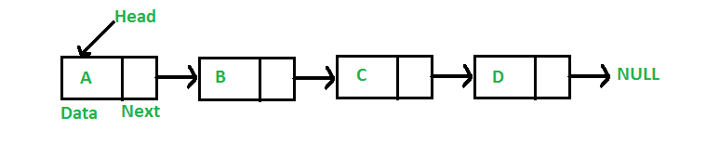

## a doubly linked list is a linked data structure that consists of a set of sequentially linked records called nodes.

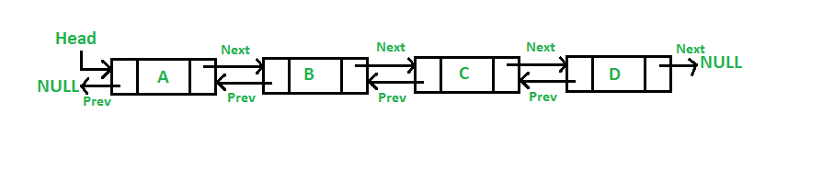

## A circular linked list is a linked list in which the last node points to the head or front node making the data structure to look like a circle. A circularly linked list node can be implemented using singly linked or doubly linked list.

## IMG_256